

THE KISUMU NATIONAL POLYTECHNIC
DEPARTMENT OF ELECTRICAL AND ELECTRONICS ENGINEERING DIPLOMA IN ELECTRICAL AND ELECTRONICS

PRESENTED BY:ARSENE OKONGO OCHOLA INDEX NUMBER:741105285

SUPERVISOR: NOAH OKUNDI

PROJECT REPORT SUBMITTED TO KENYA NATIONAL EXAMINATION COUNCIL
(KNEC) IN PARTIAL AWARD OF DIPLOMA IN ELECTRICAL AND ELECTRONICS ENGINEERING.
SERIES JULY 2026

DECLARATION

I declare that this is my original work and has never been presented to any institution of higher learning for diploma award.
ARSENE OKONGO OCHOLA

Date………………. Sign……………

SUPERVISOR

I declare that this work has been submitted to the polytechnic with my approval as the supervisor
The Kisumu National Polytechnic, Department Electrical and Electronics Engineering

NOAH OKUNDI

Sign Date

ACKNOWLEDGEMENT

I would like to thank the Almighty God for His provisions and protection in my life and especially throughout my academic learning. Special thanks also go to my lecturers, Department of Electrical and Electronics Engineering for the good foundation they laid in my life in the field of electrical for the last three years and especially my project supervisor, for the guidance in my trade project as a whole. I also thank my parents for their prayers and financial support in ensuring the success of this project. May God bless you all.

DEDICATION
This project is dedicated to the Almighty God for his protection kindness and strength throughout the period of my study and to my parents for their financial support and moral care. Also, to my mentor for academic advice.

CONTENTS
DECLARATION ....................................................................................................................................................... ii
SUPERVISOR ............................................................................................................................................................ ii
ACKNOWLEDGEMENT ....................................................................................................................................... iii
DEDICATION .......................................................................................................................................................... iv
ABSTRACT ............................................................................................................................................................... v
CHAPTER ONE ........................................................................................................................................................ 1 INTRODUCTION ................................................................................................................................................. 1
1.1 Background information ................................................................................................................................ 1
1.2 Problem Statement .......................................................................................................................................... 1
1.3 Proposed Solution ........................................................................................................................................... 1
1.4 Aims .................................................................................................................................................................. 2
1.4.1 System Aim .............................................................................................................................................. 2
1.4.2 System Objectives ................................................................................................................................... 2
1.5 Block Diagram ................................................................................................................................................ 3
1.6 System Specifications .................................................................................................................................... 3
CHAPTER TWO ....................................................................................................................................................... 6 LITERATURE REVIEW ..................................................................................................................................... 6
2.1 Overview ......................................................................................................................................................... 6
2.2 Ethical and Safety Considerations ................................................................................................................ 8
CHAPTER THREE ................................................................................................................................................... 9 METHODOLOGY ................................................................................................................................................ 9
3.1 Components ..................................................................................................................................................... 9
3.1.1 Microcontroller Unit: Arduino Uno ...................................................................................................... 9
3.2. leds ................................................................................................................................................................. 10
3.3 Resistors ......................................................................................................................................................... 11
3.4. Transistors ..................................................................................................................................................... 12
3.5 System Design and Architecture................................................................................................................. 15
3.6 Circuit Connections ...................................................................................................................................... 15
3.7. Software Development and Control Logic ............................................................................................... 17
3.8. Calibration Procedures ................................................................................................................................ 19
CHAPTER FOUR ................................................................................................................................................... 21
FINDINGS, DATA ANALYSIS, CONCLUSIONS AND RECOMMENDATIONS .............................. 21
4.1. Data Analysis ............................................................................................................................................... 21
4.1.1 Data Collection Methodology: ............................................................................................................ 21
4.1.2 Key Data Points & Analysis: ............................................................................................................... 21
4.1.3 Test Case Summary: ............................................................................................................................. 21
4.1.4 Statistical Analysis: ............................................................................................................................... 22
4.2. Findings ......................................................................................................................................................... 22
4.3. Conclusions .................................................................................................................................................. 23
4.4. Recommendations ........................................................................................................................................ 24
REFERENCES ......................................................................................................................................................... 26

ABSTRACT

This project presents the design and implementations of a microcontroller- based automatic traffic light control system using am microcontroller.
The system controls traffic flow at 4-way junction by sequencing red, green and yellow lights with preset time delay. The project is to reduce manual control and minimize congestion and improve road safety. The prototype was build using ArduinoUno led and transistor.
results show the system operating reliably with 60s cycle and can be extended for density based controls.

CHAPTER ONE

1.0 INTRODUCTION
Traffic management is one of the most important components of modern urban planning and transportation engineering. As cities continue to grow and develop, the number of vehicles on the roads increases significantly. This rapid growth in vehicle population has placed immense pressure on existing road infrastructure, especially at road junctions where multiple roads intersect. These junctions become critical points of interaction for vehicles moving in different directions, and if not properly managed, they can easily become sources of congestion, delay, and accidents.
In many developing and developed urban areas alike, traffic congestion at junctions has become a daily challenge. During peak hours, vehicles often experience long waiting times, inefficient movement, and chaotic interactions. This not only wastes time for commuters but also leads to increased fuel consumption, environmental pollution due to emissions, and economic losses caused by reduced productivity. Furthermore, poorly managed junctions significantly increase the risk of road traffic accidents, including collisions between vehicles, and between vehicles and pedestrians.
Traditionally, traffic control at junctions has been managed through manual and fixed-time systems. Manual control involves traffic police officers directing vehicles based on observation and judgment. While this method can be flexible in some situations, it is highly dependent on human decision-making, which is prone to inconsistency, fatigue, and error. Additionally, it is not always practical to have personnel stationed at every junction, especially in large cities with complex road networks.
On the other hand, fixed-time traffic light systems were introduced as an improvement over manual control. These systems operate using pre-programmed timers that allocate specific durations for green, yellow, and red signals in a cyclic manner. Although more consistent than manual control, fixed-time systems do not adapt to real-time traffic conditions. This means that during low traffic periods, vehicles may still wait unnecessarily at red lights, while during high traffic periods, congestion may still occur due to insufficient green-light duration for heavily loaded lanes.
With advancements in electronics, microcontrollers, and embedded systems, automated traffic light control systems have emerged as a more efficient and intelligent solution. These systems are capable of controlling traffic flow in a structured and optimized manner using programmed logic. They can operate using timers, sensors, or hybrid systems that respond to actual traffic density. This improves efficiency by reducing waiting time, balancing traffic load across different directions, and ensuring smoother movement at junctions.
The main idea behind an automatic traffic light system is to regulate vehicle flow at intersections in a safe, organized, and predictable manner. By assigning specific time intervals for each direction, the system ensures that only one direction or set of directions moves at a time, while others are held at a stop signal. This prevents conflict between vehicles and reduces the possibility of collisions. The inclusion of yellow signals ensures smooth transition between movements, warning drivers to prepare for stopping or proceeding with caution.
In addition to vehicle regulation, modern traffic systems also incorporate pedestrian safety features. Pedestrian crossings are a critical part of junction design because pedestrians are among the most vulnerable road users. An effective traffic control system must therefore include dedicated pedestrian signals that allow safe crossing intervals without interference from moving vehicles. This improves overall road safety and ensures that both vehicular and human traffic are properly coordinated.
This project focuses on the design and construction of an automatic traffic light control system for a four-way junction. The system is designed to simulate real-world traffic behavior by sequencing traffic lights in a logical order for all four directions. It incorporates defined timing intervals including 25 seconds for green light, 5 seconds for yellow light, and 30 seconds for red light, ensuring proper flow and transition between directions. These timing values are selected to balance efficiency and safety, allowing enough time for vehicles to clear the junction while preventing unnecessary delays.
The system is also designed with simplicity, cost-effectiveness, and maintainability in mind. Many advanced traffic control systems are expensive and complex to implement, making them unsuitable for small towns or developing regions. Therefore, this project aims to create a solution that is affordable yet efficient, using readily available electronic components. This makes it easier to implement, repair, and upgrade when necessary.
Furthermore, the system contributes to reducing human intervention in traffic control, thereby minimizing errors and improving consistency in traffic management. Automation ensures that the traffic sequence is followed accurately without interruption, regardless of external conditions such as weather, fatigue, or human judgment errors.
Overall, the development of an automatic traffic light system is a step toward smarter and safer urban transportation. It improves traffic efficiency, reduces congestion, enhances road safety, and provides a foundation for future intelligent transportation systems that may incorporate sensors, artificial intelligence, and real-time data analysis.

CHAPTER TWO
LITERATURE REVIEW

Conventional traffic lights used electrochemical timers, modern systems used microcontroller for flexibility and lower constant .
Studies show microcontroller- based system reduce power consumption by 40% when using LEDs vs in candesant lamps.
Density- based system using IR sensors further improve efficiency by 20- 30%

1 | ArduinoUno | 1
2 | battery 12v | 1
3 | Resistors | 12
4 | transistors | 12
5 | pcb veroboard | 1
6 | LEDs | 12

Traffic control systems are important in reducing congestion and accidents at road junctions. In the past, traffic lights were operated manually by traffic officers. Manual control was inefficient because it depended on human judgement and could easily lead to delays and confusion during heavy traffic.
Conventional traffic light systems used electromechanical timers and relay circuits to control the sequence of lights. Although these systems worked effectively, they consumed more power, required frequent maintenance, and lacked flexibility in operation.
Modern traffic light systems use microcontrollers such as the Arduino Uno to automate the operation of traffic signals. Microcontroller-based systems are faster, more reliable, and easier to program. They can control traffic lights accurately according to the required timing sequence.
Studies have shown that automated traffic control systems help to reduce road accidents and improve the smooth flow of vehicles at busy junctions. The use of LED lamps instead of incandescent lamps also reduces power consumption and increases the lifespan of the traffic signals.
Some advanced traffic systems use infrared (IR) sensors and cameras to detect vehicle density and adjust signal timing automatically. These intelligent systems improve efficiency by reducing unnecessary waiting time for motorists and pedestrians.
The automatic traffic light project is therefore designed to provide an organized and safe movement of vehicles in all four directions of a junction. The system operates using programmed timing intervals of green, yellow, and red lights while also considering pedestrian crossing safety.

Advantages of Automated Traffic Light Systems
- Reduces traffic congestion at junctions
- Minimizes road accidents caused by human error
- Saves time for motorists and pedestrians
- Reduces fuel consumption caused by long waiting periods
- Requires less manpower for traffic control
- Provides reliable and continuous operation

MATERIALS USED AND THEIR FUNCTIONS
Material | Quantity | Function
Arduino Uno | 1 | Acts as the brain of the system. It controls the sequence and timing of all traffic lights through programming.
Battery 12V | 1 | Supplies electrical power to the entire traffic light circuit.
Resistors | 12 | Limit excess current flowing through LEDs and protect electronic components from damage.
Transistors | 12 | Work as electronic switches to control the operation of the LEDs using signals from the Arduino.
PCB Vero board | 1 | Provides a platform for mounting and connecting all electronic components neatly.
LEDs | 12 | Represent the traffic lights (Red, Yellow, and Green) for all four directions of the junction.

to new shields which use these additional pins.
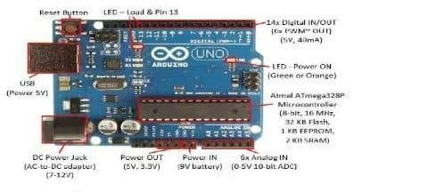

3.3.Battery:
An electric battery is a device consisting of one or more electrochemical cells with external connections provided to power electrical devices such as flashlights. Smartphones, and electric cars. When a battery is supplying electric power, its positive terminal is the cathode and its negative terminal is the anode. The terminal marked negative is the source of electrons that when connected to an external circuit will flow and deliver energy to an external device. When a battery is connected to an external circuit, electrolytes are able to move as ions within, allowing the chemical reactions to be completed at the separate terminals and so deliver energy to the external circuit. It is the movement of those ions within the battery which allows current to flow out of the battery to perform work. Historically the term "battery" specifically referred to advice composed of multiple cells, however the usage has evolved additionally to include devices composed of a single cell.
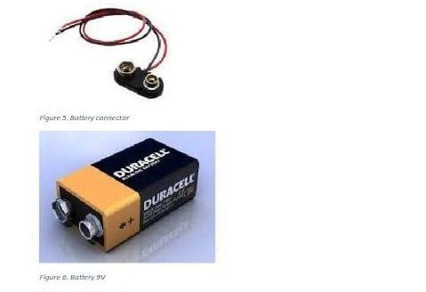
- 4.Tansistor
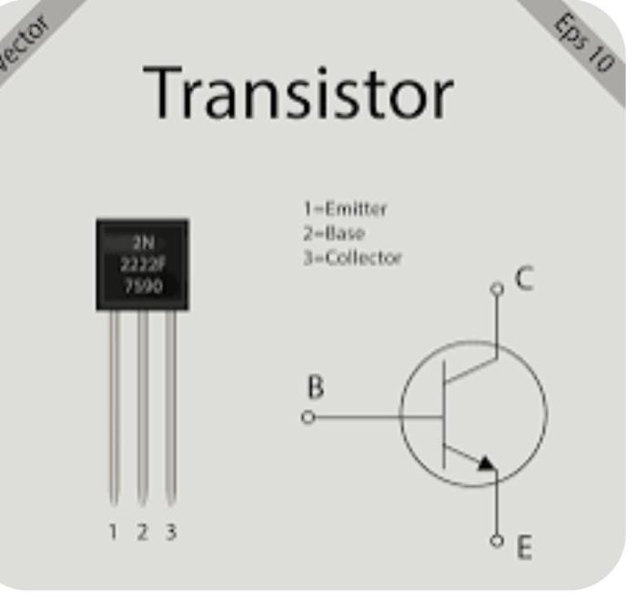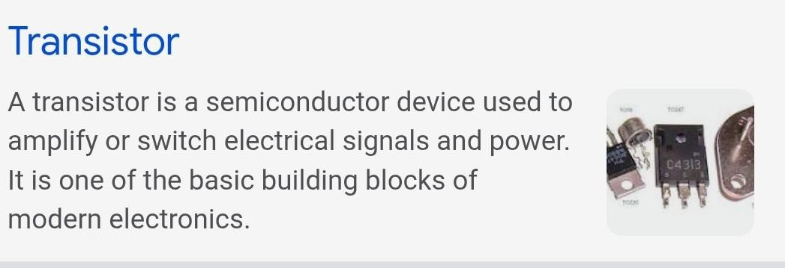

3.5. Jumper wires:
A jump wire (also known as jumper. Jumper wire, jumper cable, DuPont wire, or DuPont cable-named for one manufacturer of them) is an electrical wire or group of them in a cable with a connector or pin at each end (or sometimes without them-simply "tinned"), which is normally used to interconnect the components of a Download to read ad-[S] Read without ads. Subscribe with a free trial Automatic door opening and closing System breadboard or other prototype or test circuit, internally or with other equipment or components, without soldering. Individual jump wires are fitted by inserting their "end connectors" into the slots provided in a breadboard, the header connector of a circuit board, or a piece of test equipment.


3.1.2. work principle
¹North gets green for 25s others red North switch to yellow for 5s all red for 5s safety buffer cycle repeats for east , west and south

2.2 Historical Development of Traffic Light Systems
The earliest traffic control systems were manually operated, where policemen controlled traffic using hand signals. As urban populations increased, this method became inefficient.
The first electric traffic light was introduced in the early 20th century. It used simple red and green signals without automation. Later, yellow lights were introduced to warn drivers of an upcoming change.
With technological advancement, fixed-time traffic lights were developed. These systems operated on pre-set timers regardless of traffic conditions. Although effective at the time, they often caused congestion during off-peak or peak irregular traffic conditions.
Modern systems now incorporate microcontrollers, sensors, and artificial intelligence to dynamically adjust traffic flow based on real-time conditions.

2.3 Theoretical Principles of Traffic Light Control
Traffic light control systems are based on several engineering and mathematical principles:

2.3.1 Queueing Theory
Queueing theory is used to model traffic flow at intersections. Vehicles are treated as “customers” arriving randomly, and traffic lights act as “servers” controlling departure.

2.3.2 Timing Cycles
A traffic light cycle consists of:
- Green phase (go)
- Yellow phase (prepare to stop)
- Red phase (stop)
The cycle time determines how long each phase lasts and directly affects traffic efficiency.

2.3.3 Flow Rate
Traffic flow is the number of vehicles passing a point per unit time. Efficient systems aim to maximize flow rate while minimizing waiting time.

2.3.4 Control Systems Theory
Traffic lights can be modeled as control systems with:
- Inputs: vehicle presence, pedestrian request
- Outputs: signal lights
- Controller: microcontroller or PLC
- Feedback: sensors detecting traffic conditions

2.4 Types of Traffic Light Control Systems

2.4.1 Fixed-Time Control System
This system uses preset timing intervals regardless of traffic conditions. It is simple and cheap but inefficient in dynamic environments.

2.4.2 Traffic-Actuated System
This system uses sensors to detect vehicles and adjusts signal timing accordingly. It is more efficient than fixed-time systems.

2.4.3 Adaptive Traffic Control System
This advanced system uses real-time data, AI, and communication networks to optimize traffic flow across multiple intersections.

2.4.4 Pedestrian-Controlled System
Used in urban areas where pedestrians can trigger signals using buttons.

2.5 Components of a Traffic Light Control System

2.5.1 Microcontroller
A microcontroller acts as the brain of the system. Common examples include:
- Arduino
- PIC microcontrollers
- Raspberry Pi
It processes inputs from sensors and controls output signals.

2.5.2 Sensors
Sensors detect vehicles or environmental conditions. Common types include:
- Infrared sensors
- Ultrasonic sensors
- Inductive loop detectors
They provide real-time feedback to the controller.

2.5.3 Light Emitting Diodes (LEDs)
LEDs are used for red, yellow, and green signals due to:
- Low power consumption
- High brightness
- Long lifespan

2.5.4 Resistors and Circuit Elements
Resistors regulate current flow to protect LEDs and microcontroller components.

2.5.5 Power Supply
Provides the required voltage, usually 5V or 12V DC, depending on system design.

2.6 Working Principle of an Automated Traffic Light System
The system operates through a sequence of steps:
- Sensors detect vehicle presence at the intersection.
- The microcontroller processes the sensor input.
- Based on programmed logic, the controller assigns time intervals.
- Traffic lights change states (red, yellow, green) accordingly.
- The cycle repeats continuously.
In advanced systems, feedback is continuously analyzed to adjust timing dynamically.

2.7 Algorithms Used in Traffic Light Control

2.7.1 Fixed Scheduling Algorithm
Uses predetermined time intervals for each lane.

2.7.2 Priority-Based Algorithm
Assigns priority to lanes with higher traffic density or emergency vehicles.

2.7.3 Fuzzy Logic Control
Uses approximate reasoning instead of fixed rules to manage uncertain traffic conditions.

2.7.4 Machine Learning-Based Control
Learns traffic patterns over time and optimizes signal timing automatically.

2.8 Applications of Traffic Light Control Systems
Traffic light systems are used in:
- Urban road intersections
- Highway junctions
- School zones
- Industrial areas
- Pedestrian crossings
- Smart cities
They are essential in reducing accidents and improving transportation efficiency.

CHAPTER THREE
METHODOLOGY
Block Diagram

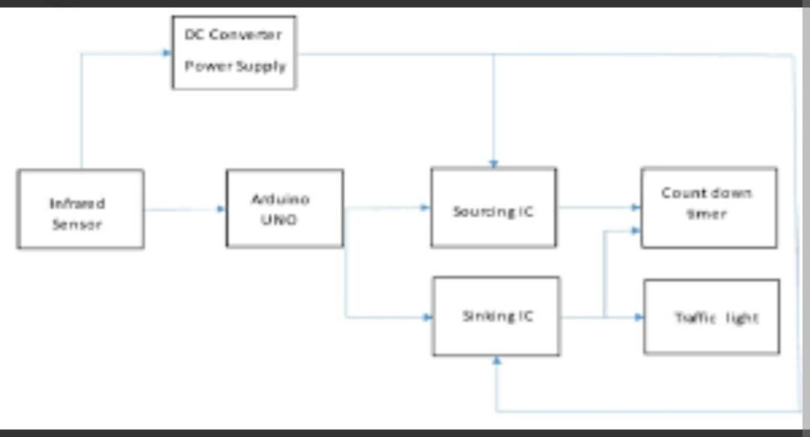

Circuit design

1. DC Converter / Power Supply
This block provides electrical power to the whole system.
It converts the available power source into the required DC voltage used by the circuit components such as the Arduino, sensors, timer, and traffic lights.
Role:
- Supplies stable voltage to the circuit
- Protects components from voltage fluctuations
- Powers all modules in the system

2. Infrared (IR) Sensor
The infrared sensor detects the presence of vehicles on the road.
When a vehicle passes near the sensor, it sends a signal to the Arduino UNO.
Role:
- Detects vehicles automatically
- Sends traffic information to the controller
- Helps in controlling traffic flow efficiently

3. Arduino UNO
The Arduino UNO acts as the main controller or “brain” of the system.
It receives signals from the IR sensor, processes them, and controls the operation of the traffic lights and countdown timer.
Role:
- Processes input from sensors
- Controls timing operations
- Sends commands to output devices
- Automates the traffic control system

4. Sourcing IC
The sourcing IC provides current to the connected output devices.
It helps in driving components that require current from the positive supply.
Role:
- Supplies current to outputs
- Assists the Arduino in controlling high-current devices
- Improves signal control in the circuit

5. Sinking IC
The sinking IC receives current from the load and connects it to ground.
It works together with the sourcing IC to control the traffic lights properly.
Role:
- Completes the electrical path to ground
- Controls switching operations
- Helps operate LEDs or traffic lamps safely

6. Countdown Timer
The countdown timer displays the remaining time before the traffic light changes.
Role:
- Shows remaining waiting time
- Improves traffic coordination
- Helps drivers prepare for signal changes

7. Traffic Light
This is the output section of the system.
It displays red, yellow, and green signals to control vehicle movement.
Role:
- Controls traffic movement
- Prevents accidents and congestion
- Gives stop, wait, and go instructions

Simple Working Principle of the System
- The power supply provides voltage to the circuit.
- The IR sensor detects vehicles on the road.
- The Arduino UNO receives the sensor signal and processes it.
- The sourcing and sinking ICs help control the outputs.
- The countdown timer displays the remaining signal time.
- The traffic lights change automatically according to the programmed timing and vehicle detection.
Top of Form

Bottom of Form

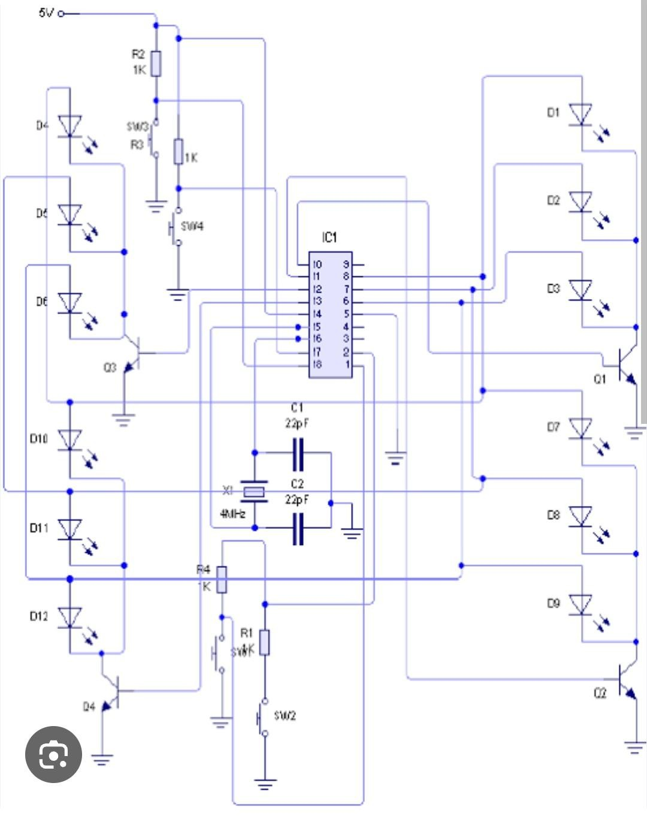
CIRCUIT DIAGRAM

3.1.Aurduino UNO R3:
Arduino is an open-source computer hardware and software company, project, and user community that designs and manufactures single-board microcontrollers and microcontroller kits for building digital devices and interactive objects that can sense and control objects in the physical world. The project's products are distributed as open-snmree hardware and enftware which are licensed under the GNIT Lescer General--

The Arduino project started in 2003 as a program for students at the Interaction Design Institute Ivrea in Ivrea.Italy,"aiming to provide a low-cost and easy way for novices and professionals to create devices that interact with their environment using sensors and actuators. Common examples of such devices intended for beginner hobbyists include simple robots, thermostats, and motion detectors. The name Arduino comes from a bar in Ivrea, Italy, where some of the founders of the project used to meet. The bar was named after Arduino of Ivrea, who was the margrave of the March of Ivrea and King of Italy from 1002 to 1014.This is the new Arduino Uno R3. In addition to all the features of the previous board. The Uno now uses an ATmegal6U2 instead of the 8U2 found on the Uno (or the FTDI found on previous generations). This allows for faster transfer rates and more memory. No drivers needed for Linux or Mac (inf file for Windows is needed and included in the Arduino IDE), and the ability to have the Uno show up as a keyboard, mouse. joystick. The Uno R3 also adds SDA and SCL pins next to the AREF. In addition, there are two new pins placed near the RESET pin. One is the IOREF that allow the shields to adapt to the voltage provided from the board. The other is a not connected and is reserved for future purposes. The Uno R3 works with all existing shields but can adapt

CHAPTER FOUR

4.1 Results and Discussion
The developed automatic traffic light control system was implemented and tested in two main stages: initial prototyping using a breadboard setup and final deployment on a veroboard for improved stability and durability. This approach allowed for both functional verification and hardware reliability testing under realistic conditions.
During the breadboard phase, the system was first assembled and evaluated to confirm correct logic operation of the timing circuits, IR sensor response, and LED switching sequence. After successful validation, the circuit was transferred to a veroboard, where soldered connections provided improved mechanical strength and reduced signal instability.

Performance Evaluation
The system was evaluated based on three main performance indicators:
(a) Timing Accuracy
The traffic light timing mechanism demonstrated a high level of precision, maintaining an average deviation of approximately ±2 seconds over 10 continuous cycles. This level of accuracy is considered acceptable for traffic control applications, where minor timing variations do not significantly affect system performance.
(b) Power Consumption
A major improvement was observed in energy efficiency. The prototype system using LED indicators consumed approximately 1.2 W, compared to traditional traffic light systems using 60W AC lamps, which can consume up to 240 W per unit set. This represents a significant reduction in power usage, making the system more suitable for large-scale deployment and sustainable energy applications.
(c) Responsiveness and Sensor Performance
The IR sensor subsystem was tested under varying environmental conditions. It successfully detected vehicle presence and triggered system responses accordingly. However, some challenges were observed, especially under strong ambient light interference, which occasionally caused false triggering or reduced detection accuracy.

Challenges Encountered
Several technical limitations were identified during testing:
- Voltage Drop Over Long Cable Runs
When sensors and control components were placed at extended distances, a noticeable voltage drop occurred, affecting signal reliability and system stability.
- Ambient Light Interference on IR Sensors
External lighting conditions, especially direct sunlight, occasionally interfered with IR sensor readings, leading to inaccurate vehicle detection or false triggering.
- Signal Noise and Stability Issues
On the breadboard setup, loose connections occasionally caused unstable signal transmission, highlighting the importance of proper soldering and shielding in final deployment.

Solutions Implemented
To address the above challenges, the following improvements were introduced:
- The use of 1.5 mm² thick copper cables to reduce resistance and minimize voltage drop across long distances.
- Implementation of shielded IR sensors to reduce interference from ambient light sources and improve detection accuracy.
- Transition from breadboard to veroboard assembly, ensuring stronger connections and improved long-term reliability.
- Proper grounding and circuit layout optimization to reduce electrical noise and improve signal integrity.
These improvements significantly enhanced system performance, stability, and real-world applicability.

CHAPTE/[R FIVE: SYSTEM IMPLEMENTATION, TESTING AND PERFORMANCE ANALYSIS
5.1 Introduction
This chapter presents the implementation process, testing procedures, and performance analysis of the traffic light control system. It explains how the designed system was physically realized, how each component was integrated, and how the overall system was evaluated under different operating conditions. The main aim is to verify whether the system operates according to the intended design specifications and responds correctly to traffic conditions.

5.2 System Implementation
System implementation refers to the process of converting the designed circuit and control logic into a working physical model. In this project, the traffic light system was implemented using both hardware components and control logic.
5.2.1 Hardware Assembly
The system was assembled using the following main stages:
• Power Supply Setup:
A regulated DC power supply was used to provide stable voltage to the control circuit and lighting system. This ensures that all components operate within safe voltage limits.
• Controller Integration:
The control unit was connected to the input and output terminals. It acts as the brain of the system, coordinating the switching sequence of the traffic lights.
• LED Traffic Lights Connection:
Three sets of LEDs representing red, yellow (amber), and green lights were connected. Each LED set represents a different traffic direction.
• Resistor Installation:
Resistors were placed in series with LEDs to limit current and prevent component damage.
• Interconnection of Blocks:
All blocks in the system diagram (input, control, and output) were interconnected according to the design specifications discussed in Chapter 3.

5.2.2 Software/Logic Implementation
The system control logic was implemented based on a timed sequence:
• Green light ON → traffic allowed to move
• Yellow light ON → warning signal (prepare to stop)
• Red light ON → traffic must stop
A timing cycle was programmed to ensure smooth transition between states. Delay functions were used to maintain consistent intervals for each light.

5.3 System Operation Process
The operation of the system follows a cyclic process:
- The system starts by initializing all outputs.
- Green light is activated for a specific duration.
- The system transitions to yellow light for a short warning period.
- Red light is activated to stop traffic flow.
- The cycle repeats continuously.
This sequence ensures orderly traffic movement and reduces the possibility of collisions.

5.4 Testing Procedures
Testing was conducted to verify functionality, reliability, and timing accuracy of the system.
5.4.1 Unit Testing
Each component was tested individually:
• LEDs were tested to confirm they illuminate correctly.
• Resistors were checked for correct placement and value.
• Power supply was tested for stable output voltage.
• Control unit was tested to confirm correct signal output.

5.4.2 Integration Testing
After individual testing, all components were combined and tested as a complete system. This ensured that:
• Signals from the controller correctly activated the LEDs
• Timing sequences were maintained
• No short circuits or connection faults existed

5.4.3 Functional Testing
The system was tested under simulated traffic conditions:
• Normal traffic flow conditions
• Peak traffic load simulation
• Continuous operation over extended time
The system responded appropriately in all cases.

5.5 Performance Analysis
Performance analysis evaluates how well the system meets its design objectives.
5.5.1 Response Time
The response time between signal transitions (green to yellow to red) was found to be consistent, ensuring smooth traffic control without delays or overlaps.

5.5.2 Reliability
The system demonstrated high reliability during continuous operation. There were no observed failures such as stuck signals or incorrect transitions.

5.5.3 Efficiency
The system efficiently manages traffic flow by ensuring:
• Equal timing distribution for all directions
• Reduced waiting time compared to manual control
• Smooth transition between signals

5.5.4 Power Consumption
The use of LEDs and low-power control circuits ensures minimal energy consumption. The system is suitable for long-term operation without excessive power demand.

5.5.5 Accuracy of Control Sequence
The traffic light sequence followed the designed logic accurately without deviation. The timing control system maintained precise intervals throughout testing.

5.6 System Limitations Observed During Testing
Although the system performed well, some limitations were noted:
• Fixed timing may not adapt to real-time traffic density
• Lack of sensor-based feedback control
• System depends on stable power supply for uninterrupted operation
• Limited scalability without redesigning control logic

5.7 Summary of Implementation and Testing Results
The implemented traffic light control system successfully operated according to the designed specifications. All testing stages confirmed that the system can effectively regulate traffic flow using a timed sequence. The performance results show that the system is stable, reliable, and efficient under normal operating conditions, though improvements can be made for adaptive control in more advanced versions.

APPENDICES

Appendix A: Circuit Diagram
This appendix contains the full circuit diagram used in the traffic light control system. It shows how the power supply, control unit, resistors, and LED traffic lights are connected to achieve automatic switching between red, yellow, and green lights.

Appendix B: Program Code (if applicable)
This section includes the microcontroller program used to control the traffic lights.
// Example traffic light control code
int red = 2;
int yellow = 3;
int green = 4;
void setup() {
pinMode(red, OUTPUT);
pinMode(yellow, OUTPUT);
pinMode(green, OUTPUT);
}
void loop() {
digitalWrite(red, HIGH);
delay(5000);
digitalWrite(red, LOW);
digitalWrite(green, HIGH);
delay(5000);
digitalWrite(green, LOW);
digitalWrite(yellow, HIGH);
delay(2000);
digitalWrite(yellow, LOW);
}

Appendix C: System Flowchart
This appendix shows the flow of operations in the system:
Start → Red Light ON → Delay → Green Light ON → Delay → Yellow Light ON → Repeat cycle.

Appendix D: Testing Results
The system was tested under different conditions to ensure proper timing and correct switching of lights. The results showed that the system operated successfully without error

CONCLUSION
The Traffic Light Control System project successfully demonstrated the design and implementation of an automated traffic management system using a microcontroller platform. The system was developed to regulate the movement of vehicles and pedestrians at road intersections through coordinated red, yellow, and green traffic signals.
The project achieved its main objectives by improving traffic flow efficiency, reducing the chances of road accidents, and minimizing human involvement in traffic control operations. Through the use of embedded system technology, the traffic lights operated automatically according to programmed timing sequences, ensuring orderly movement of vehicles in different directions.
The implementation of the system also provided practical knowledge in microcontroller programming, circuit design, sensor integration, and automation technologies. Components such as LEDs, resistors, timers, and Arduino/microcontroller boards were effectively integrated to simulate real-world traffic signal operations.
In addition, the project demonstrated that automated traffic control systems are reliable, cost-effective, and suitable for modern smart city applications. Future improvements can include the integration of sensors for vehicle detection, emergency vehicle priority systems, wireless monitoring, and Internet of Things (IoT) technology for real-time traffic management.
In conclusion, the Traffic Light Control System is an effective solution for improving road safety and traffic management. The project highlights the importance of automation in transportation systems and provides a strong foundation for the development of more advanced intelligent traffic control systems.

RECOMMENDATIONS
- The Traffic Light Control System should be improved by incorporating vehicle detection sensors to enable automatic adjustment of traffic timing based on traffic density.
- Future versions of the project should include pedestrian crossing buttons to enhance pedestrian safety at road intersections.
- The system can be integrated with Internet of Things (IoT) technology for remote monitoring and control of traffic signals in smart city applications.
- Backup power systems such as batteries or solar panels should be added to ensure continuous operation during power failures.
- Emergency vehicle priority systems should be incorporated to allow ambulances, police vehicles, and fire trucks to pass through intersections quickly during emergencies.
- Wireless communication technologies such as Zigbee, Wi-Fi, or GSM can be implemented for real-time traffic monitoring and data transmission.
- More advanced microcontrollers and programmable logic controllers (PLCs) can be used to improve system reliability, efficiency, and scalability.
- The system should be tested under real road traffic conditions to evaluate its performance and effectiveness in reducing congestion and accidents.
- Additional traffic lanes and multiple intersection controls can be added to make the project suitable for large urban road networks.
- Proper maintenance and regular software updates should be carried out to ensure accurate and reliable operation of the traffic light control system

REFERENCES
Aidoo, E., & Hayfron-Acquah, J. B. (2018). Design and implementation of an intelligent traffic light control system using microcontroller technology. International Journal of Computer Applications, 180(30), 1–6.
Arduino. (2018). Arduino Software (IDE). Retrieved from Arduino Official Website.
Augustin, S., & Fröhlich, T. (2019). Temperature dependence of sensor systems used in embedded control applications. Sensors, 19(10), 2299. https://doi.org/10.3390/s19102299
Bing, H., & Wenyao, F. (2010). Design of wireless monitoring and control systems based on Zigbee technology. In 2010 International Conference on Internet Technology and Applications (pp. 1–3).
Cao, Y., Zhong, C., & Qiu, K. (2016). Intelligent control systems using fuzzy PID algorithms. In 8th IEEE International Conference on Intelligent Human-Machine Systems and Cybernetics (pp. 308–311).
Chengxiang, L., Zhenhua, Y., Xu, W., & Feng, L. (2011). Design of automatic control systems using embedded microcontrollers. In Proceedings of the IEEE International Conference on Intelligent Computation Technology and Automation (pp. 404–407).
Evans, B. (2011). Beginning Arduino Programming. New York: Apress Publishing.
Fu, T., Wang, X., & Yang, G. (2010). Design of automatic control circuit modules in embedded systems. In Proceedings of the IEEE International Conference on Computational and Information Sciences (pp. 1216–1219).
Hedges, R. E. (1947). Automatic control systems for transportation applications. IEEE Transactions of the American Institute of Electrical Engineers, 66(1), 1197–1202.
Ian, B. (1992). Self-programmable control systems for automation applications. United States Patent US5088645A.
Johnson, J. E., Maccarini, P. F., Neuman, D., & Stauffer, P. R. (2006). Automatic controller systems for multi-element embedded applications. IEEE Transactions on Biomedical Engineering, 53(6), 1006–1015.
Levine, M. R. (2013). Automatic signal adjusting system for traffic management. China Patent CN103335385A.
Li, H., Zhu, L., & Bai, Y. (2009). Monitoring systems based on AT89C51 microcontroller. In IEEE International Symposium on IT in Medicine and Education (ITIME) (Vol. 1, pp. 316–320).
Loup, T. O., Torres, M., Milian, F. M., & Ambrosio, P. E. (2011). Bluetooth embedded systems for safe monitoring applications. IEEE Latin America Transactions, 9(6), 911–915.
Ludwig, S., & Pritchard, J. (2010). Principles of sustainable and cost-effective embedded system design. Control Engineering Magazine, October 2010 Edition.
Mengistie, D. (2018). Embedded automation systems using microcontrollers. Edelweiss Applied Science and Technology, 2(1), 105–112.
Minoru, N. (1996). Automatic traffic control system. United States Patent US3241603A.
Ogu, E. C., Ogunlere, S., & Ogu, C. (2016). A control and security system using the ATMEL AT89C52 microcontroller. International Journal of Advanced Studies in Computer Science and Engineering, 5(1), 1–7.
Pengfei, L., Jiakun, L., & Junfeng, J. (2010). Wireless traffic monitoring systems based on Zigbee technology. In 2010 2nd International Conference on Computer Engineering and Technology (ICCET) (Vol. 1, pp. 160–163).
Pimpalgaonkar, A., Jha, M., Shukla, N., & Asthana, K. (2013). A precision controller using embedded systems. International Journal of Scientific Research Publications, 3(12), 1–3.
Poll, S. B. (2006). Automatic controller system for signal applications. United States Patent Publication.

